Delivery 2

Física orientada a la Modelització i Animació Realista

Júlia Gasull i Navarro

Junjie Ji Chen

Aarón Acosta Fernández

# 

# Index

**Delivery** **3**

Exercise 1 3

Exercise 2 4

Exercise 3 5

Exercise 4 6

Exercise 5 7

# Delivery

## Exercise 1

**Find out a sequence of transformations which applied to {B} generate the systems {J} and {I}, respectively.**

|  |  |
| --- | --- |
| **{System_from} → {System_to}** | **How to** |
| **{B} → {J}** | 1. troty(γ-90) |
| **{J} → {I}** | 1. trotz(δ) → e.g. (z1 → z’) 2. troty(ωOrb*t) → point at Io at time=t 3. transl(ROrb,0,0) → move to Io |

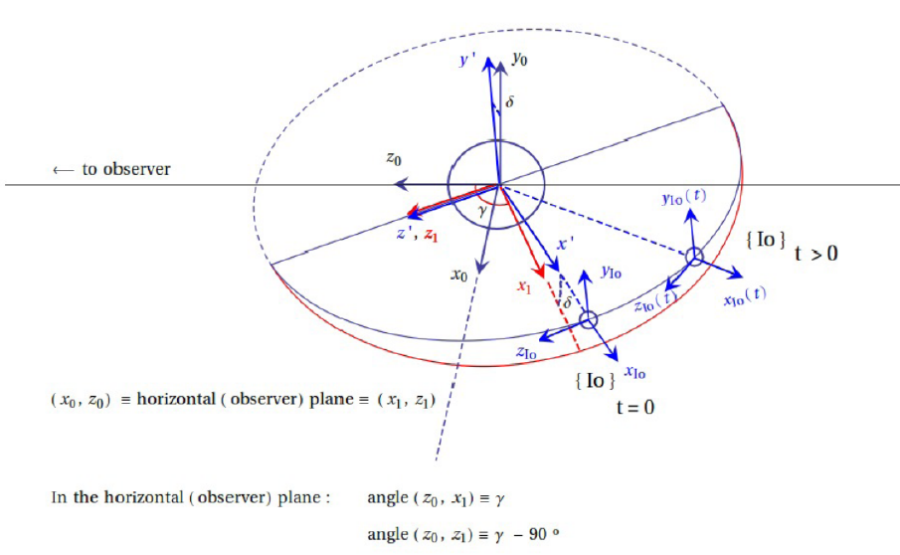

## Exercise 2

Write on paper the (matrix) equations that allow for finding the coordinates of a point P in the {B} system at any time t, assuming such coordinates are known in the systems {J} or {I}, in terms of Delta, Gamma and the data (provided in the file construccio.pov).

* wJup ≡ Jupiter’s rotation angular velocity
* wOrb ≡ Io’s orbital angular velocity
* wIo ≡ Io’s angular velocity ≡ Io’s orbital angular velocity
* RJup ≡ Jupiter’s radius
* RIo ≡ Io’s radius
* Rorb ≡ Io’s orbit radius

You will need such equations for the calculation of point #4.

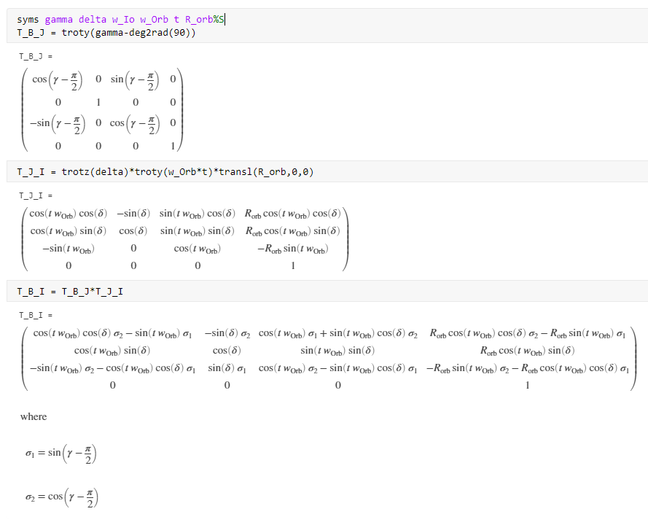

## 

## Exercise 3

In the file construccio.pov, apply the appropriate transformations identified in section 1 for Jupiter and Io objects and to its respective systems {J} and {I}, so that all of them are located properly in the observer system {B}. Then generate an animated sequence displaying one revolution of Io around Jupiter, showing also the reference frames attached to the two objects (note that in the file construccio.pov both the orbit radius and satellite radius have been modified -i.e. they are not set to scale- so that the visualization is easier, as an artificially ’big’ Io is renderized).

* Video: [lab2-ex3.mp4](https://drive.google.com/file/d/158E8G0gYRiJteHRDo-YreE4PpP5ZlTa-/view?usp=sharing)

## 

## Exercise 4

Display of Io’s transit: Introduce the same transformations in the file transit:pov (this time the orbit and satellite radius correct values have been restored, the size of the satellite is now tiny compared to Jupiter’s size) and make an mpg animation with a time span 0:68 < t < 0:69 (A few still images at different times can be checked with the clock variable being set via a command line option, as in, for example, povray +K0.685 transit.pov, should we wish to set the clock value to 0.68 . Remember that time is used in units of one orbit period). Although the size of Io is very small, the position’s camera has been set very close to it during the transit (provided the transformations you entered are correct). Using the matrix equations found in point #2, compute the position of Io at t = 0,685 in the observer {B} reference frame, and using the camera location defined in the transit.pov file, compute and report the ratios of the distances camera-Jupiter/camera-Io.

* Video 0:68 < t < 0:69:
  + Video: [lab2-ex4.mp4](https://drive.google.com/file/d/1ua64JkIWpoB2YFB74xqp4vGpCtgZe3Li/view?usp=sharing)
* at t = 0.685
  + Image:

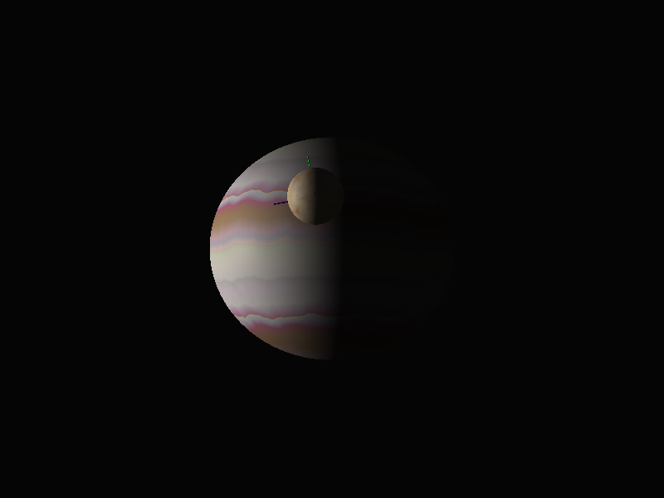

* + Position:

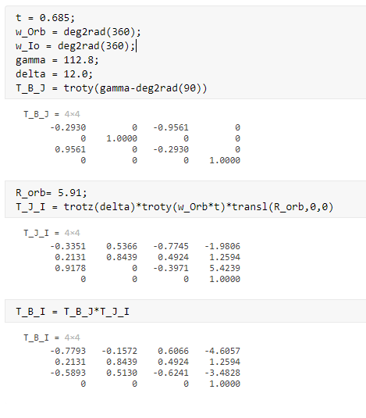

## Exercise 5

Moving observer:

* Place the Sun (light-source) in the position <-2000,100,25000>.
* As for the observer location (camera position in the code), modify (see the note below) the z coordinate so that at t0 = 0:68 we have z = 22 whilst at t1 = 0:69 it’s z = 6.6.
* Generate again the mpg animation with a time span 0:68 < t < 0:69 .
  + Suggestion: make z depend on time via z(t) = A + B (t1-t)^n with both n = 2 and n = 4 and choose A and B such that the above conditions for z at times t0 and t1 are fulfilled.

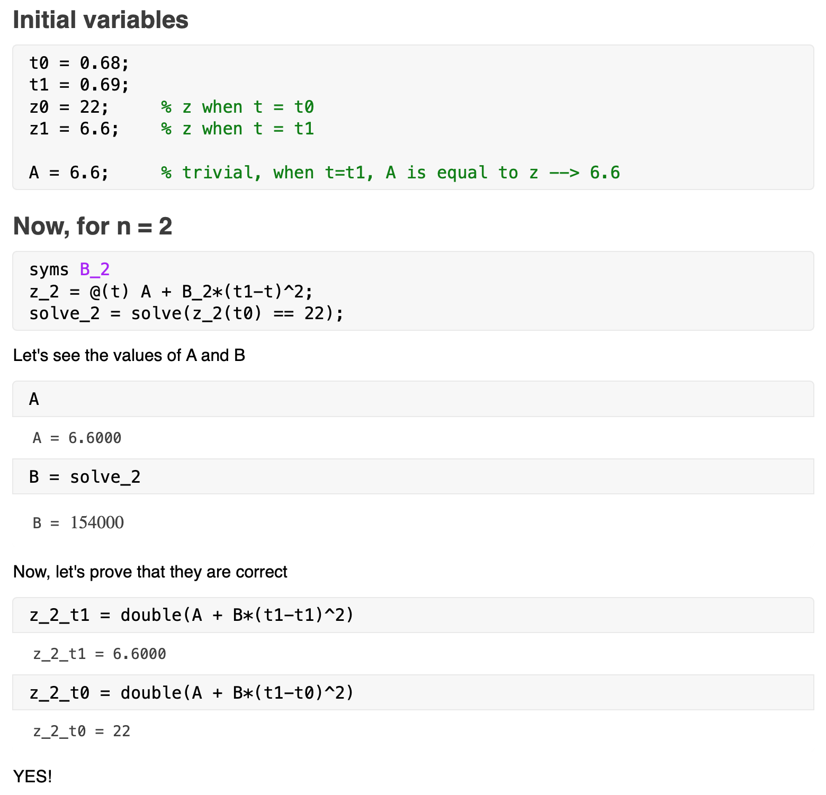

Then, the equation is:

* Video 0:68 < t < 0:69:
  + Video: [lab2-ex5-n2.mp4](https://drive.google.com/file/d/1eOvsahWQ0BcdoU1ELF7M1fRgoTP4nCEZ/view?usp=sharing)

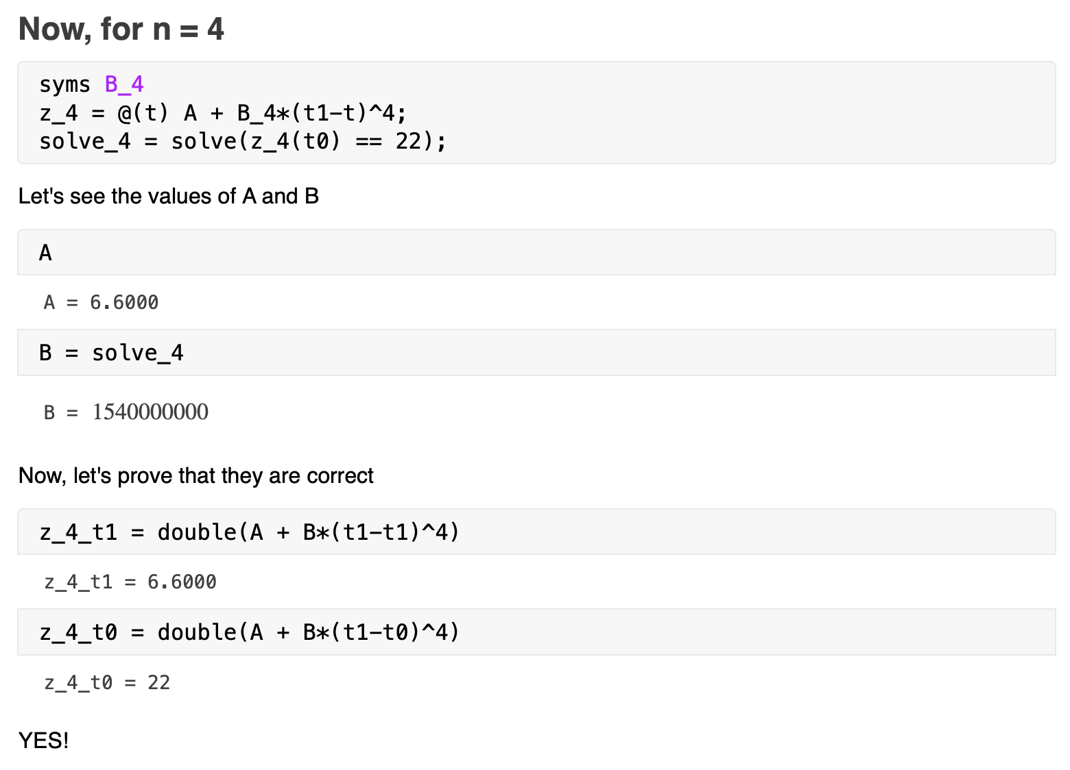

Then, the equation is:

* Video 0:68 < t < 0:69:
  + Video: [lab2-ex5-n4.mp4](https://drive.google.com/file/d/1dpi-vZj-TUSQ-JS242UPF6o4SKIpOerm/view?usp=sharing)